Practical 01 :

Arithmetic Program :

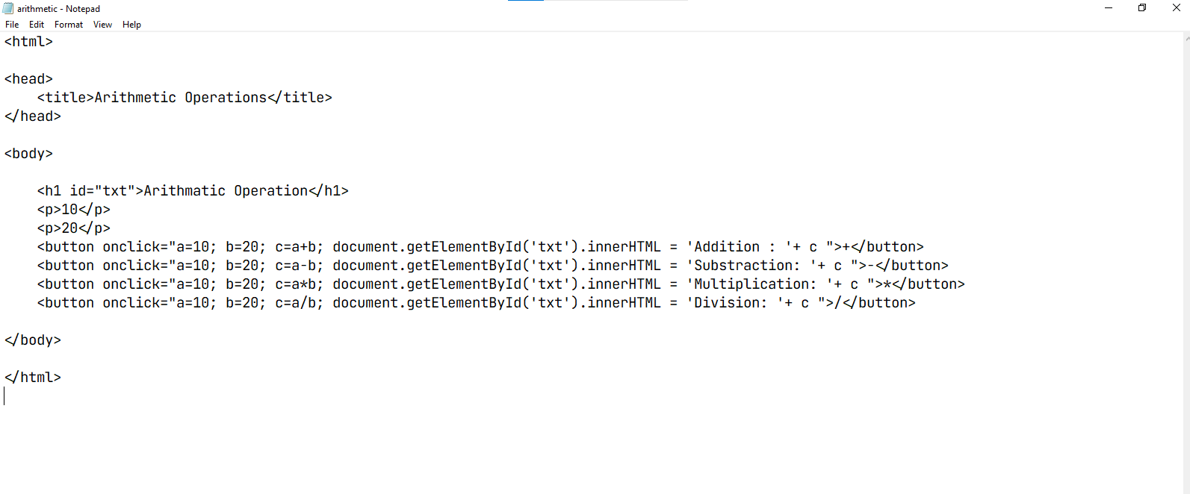

Arithmetic O/P

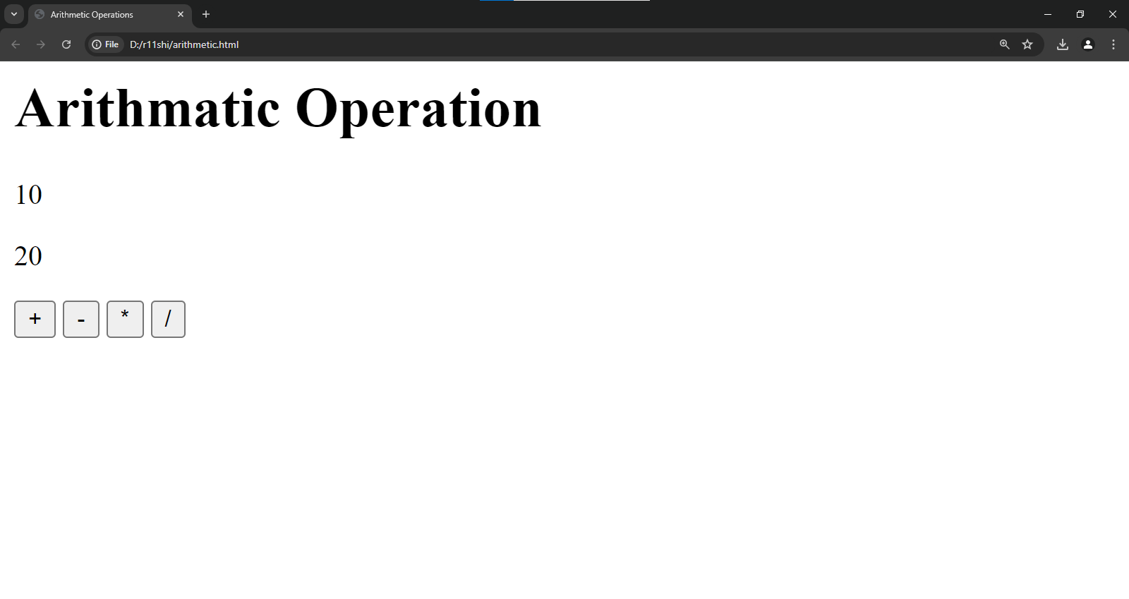

Hello world - Program  
 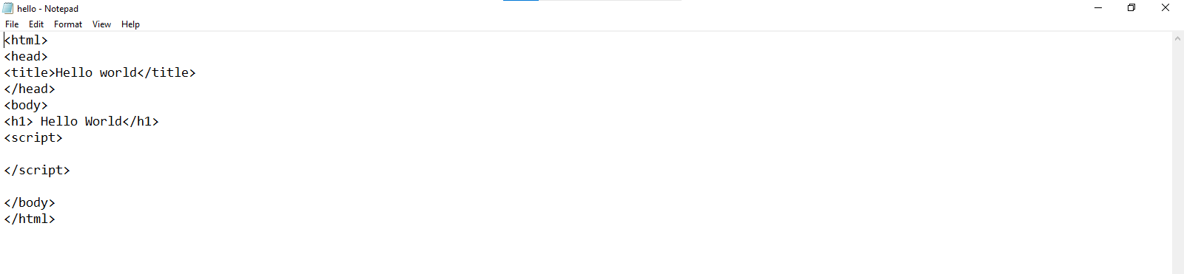

Hello world - O/P

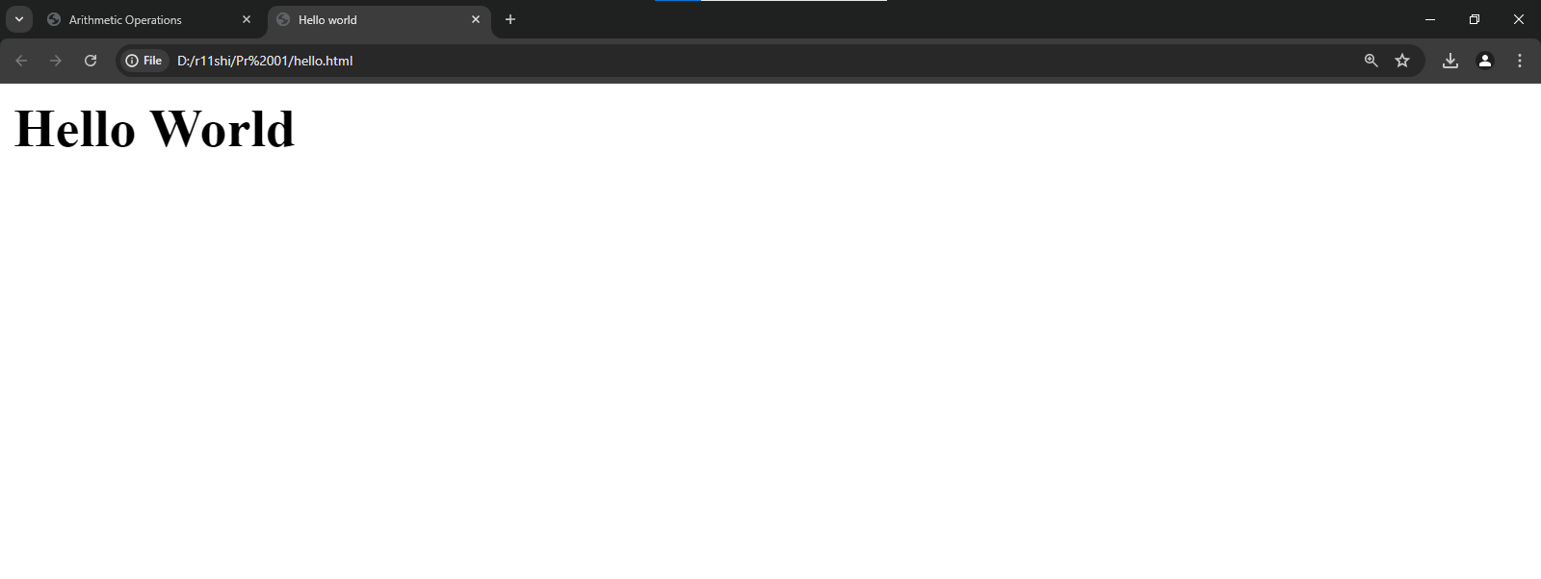

Practical 02  
  
Program 1 : Code

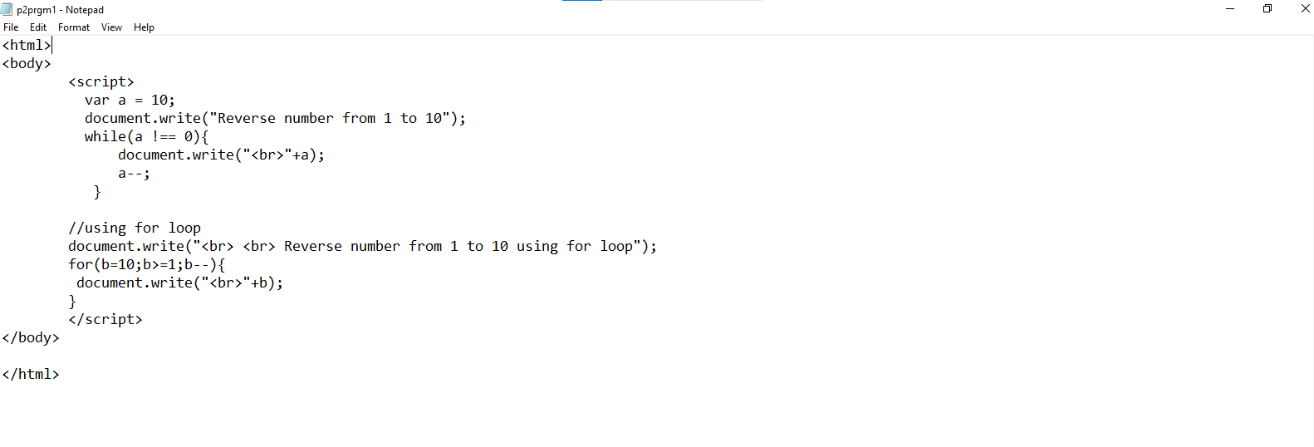

Program 1 : Output

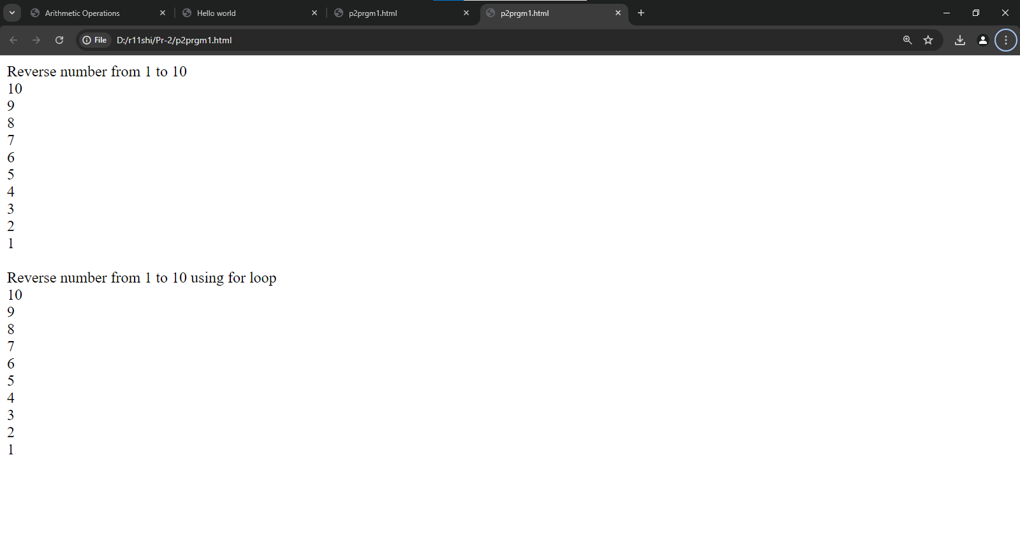

Program 2 : Code